General claims (structure ↔ dynamics ↔ stability)

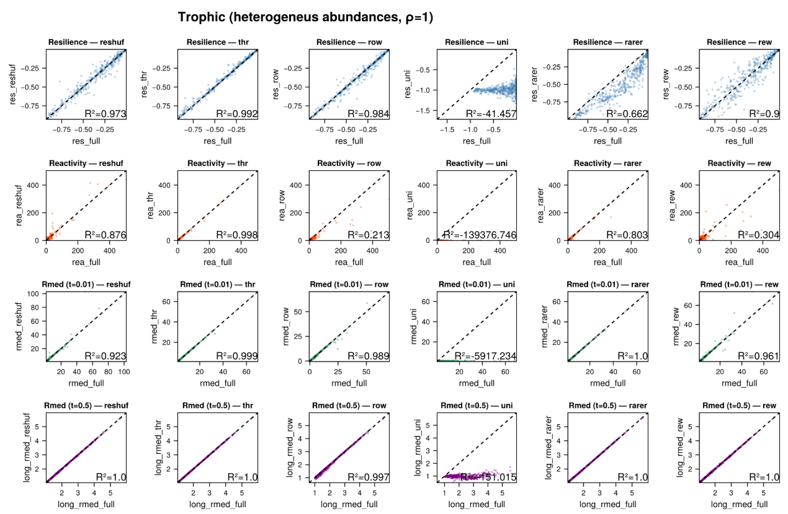

**Claim 1. Time scale dominance**

Heterogeneity in species time-scales (the **u** vector) is the primary determinant of predictability across dynamics. **Homogenizing time-scales** is consistently the most destructive operation for predictability—across resilience, reactivity, and median return rates.

**Figure 1: Uniform u crushes predictability.**

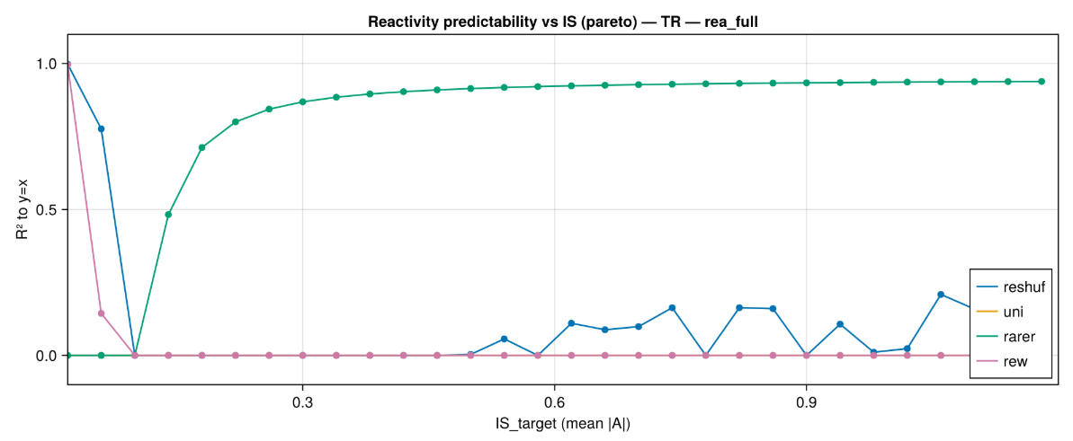 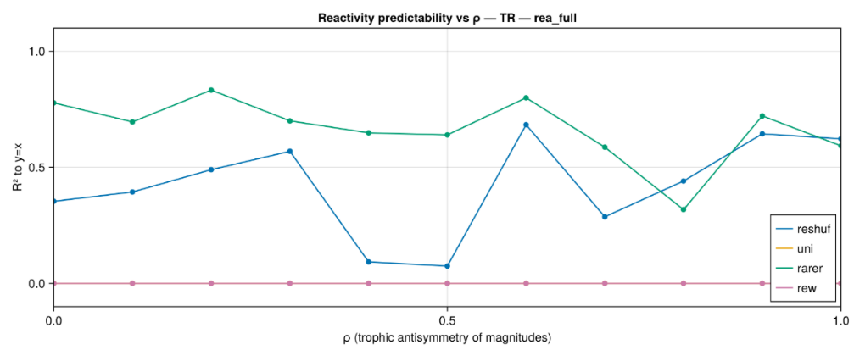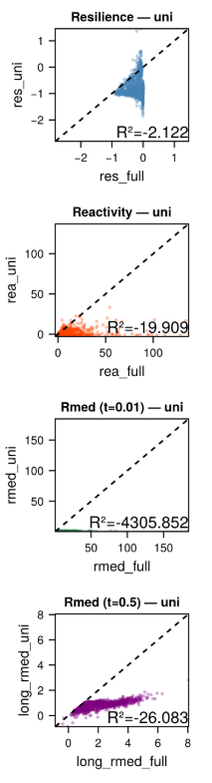

**Claim 2. Coarse over detail**

Most community-level responses are governed by a **subset of strong interactions among common species.** Modifications that mainly target weak links **(e**.g., thresholding 20%) or rare species have low to moderate influence on most dynamics, except for resilience when interaction strength is high or trophic asymmetry is very low.

**Figure 2: Weak-link pruning is mostly irrelevant, except for Resilience at high IS.**R² vs **IS** for **step = thr** and **step = rarer**. Near-flat, high R² for reactivity and Rmed; declining R² for resilience as IS increases.

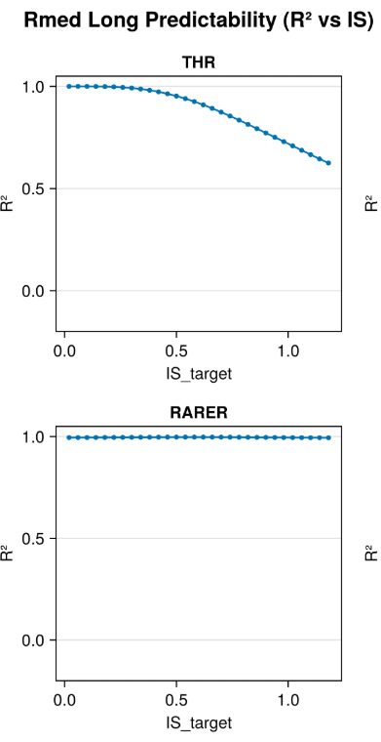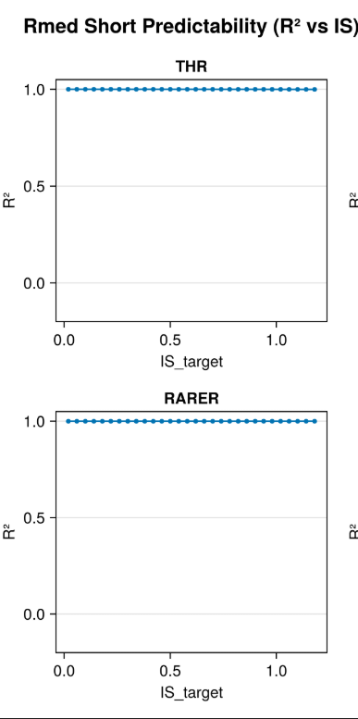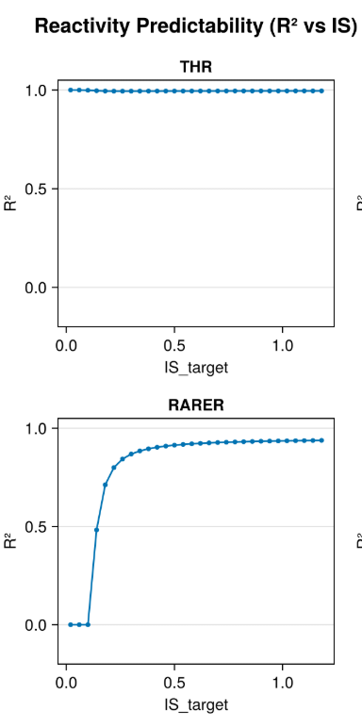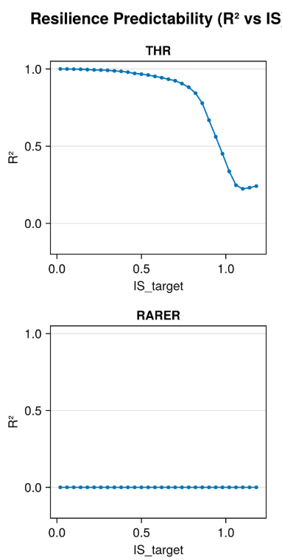

**Claim 3. Distribution of IS and topology have similar relevance (in trophic webs).**

Changing **who carries** strong interactions (reshuffling magnitudes among pairwise interactions) degrades predictability only when it **breaks trophic antisymmetric** **at the pair level.** If pairwise magnitudes are preserved, effects are minor and show up mostly in resilience (the most sensitive endpoint).

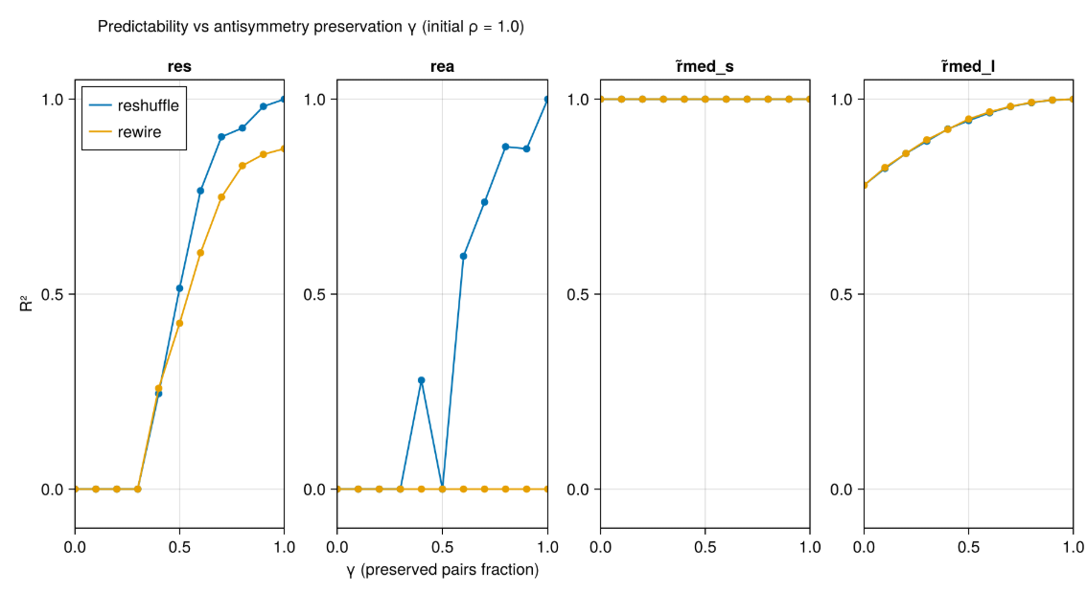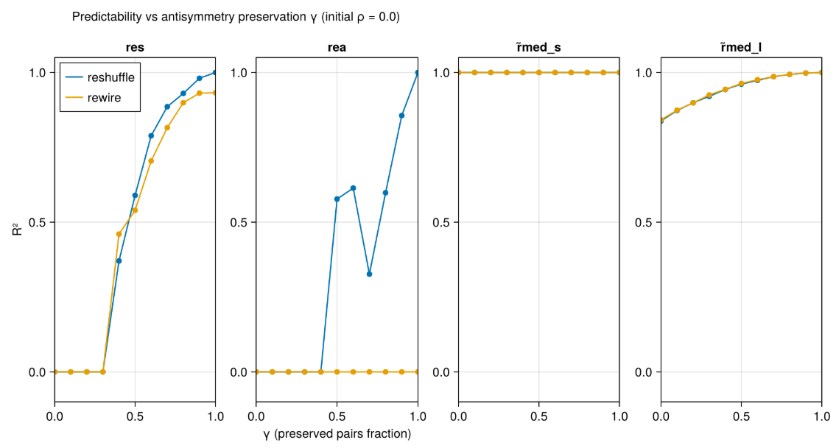**Figure 3: Placement matters only if pair antisymmetry is broken**

**Claim 4. Interaction strength sets the regime.**

As **IS** (mean |A|) increases, network-level modifications become increasingly consequential—**primarily for resilience**, and to a lesser extent for reactivity; at low IS, abundance time-scales dominate and “touch-A” steps have little impact.

**Figure 4. IS governs when structure kicks in.** For each **step ∈ {reshuf, rew, row, thr}**, line of R² vs **IS**; facet by metric.

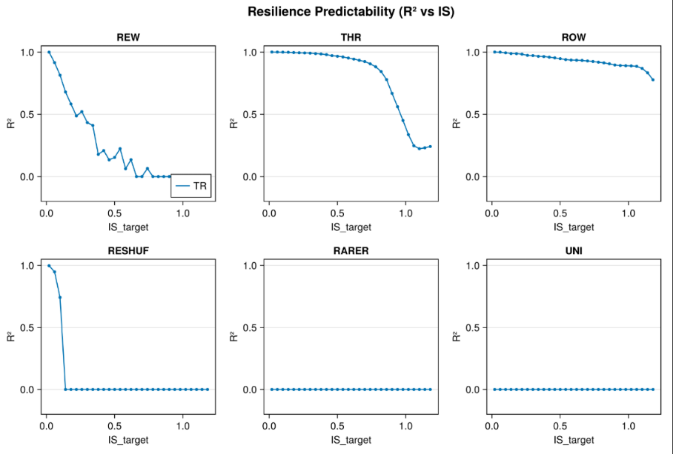This does not happen for short rmed since it is always driven by the time scale vector

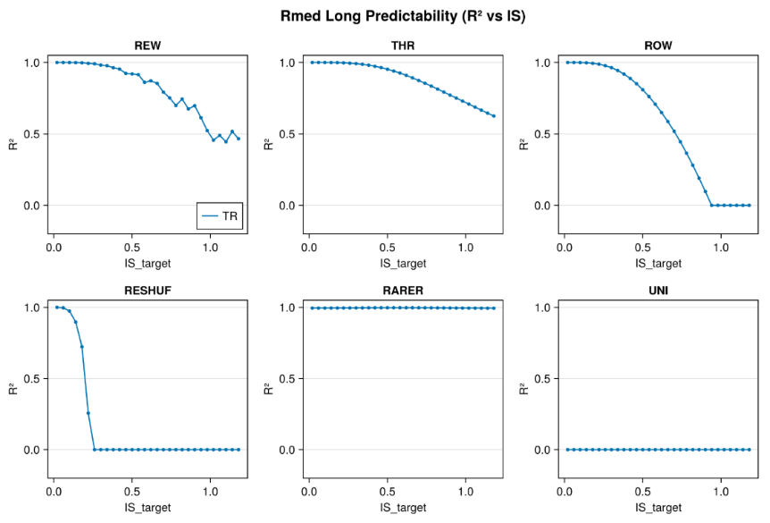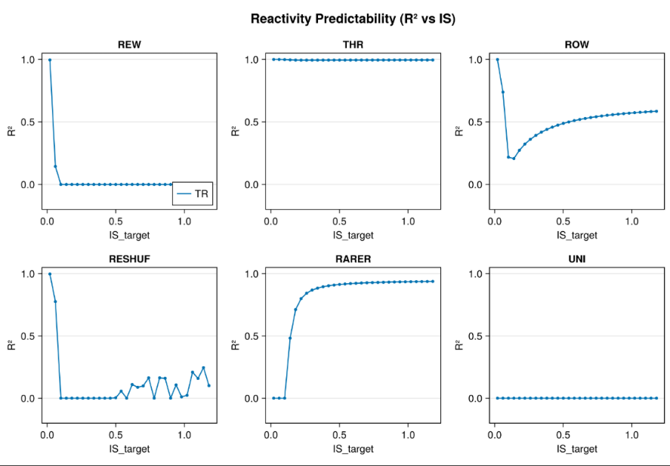

**Claim 5. Antisymmetry tunes sensitivity (step × ρ interactions).** The **level of trophic antisymmetry (ρ)** modulates which simplifications matter:

* **Row-averaging:** reactivity predictability is **low at low ρ, high at high ρ**.

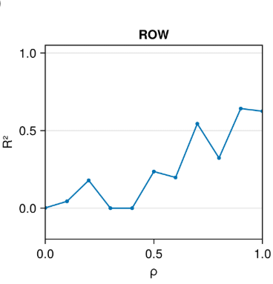

* 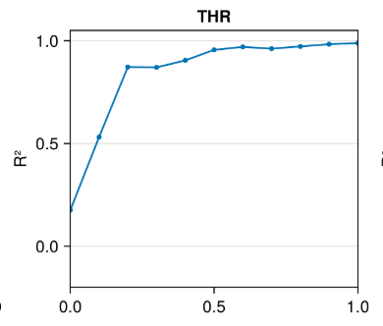Thresholding: impact on resilience decreases with **ρ**.
* 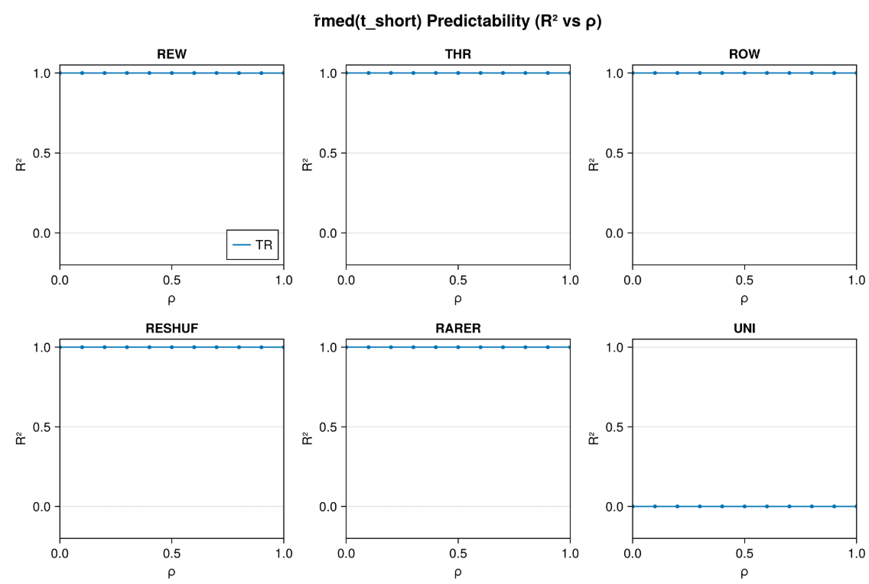**Median recovery** shows **no systematic dependence on ρ** (within the tested range).

**Claim 6. Two-stage recovery, generally.**

**Early dynamics are abundance-paced and largely insensitive to wiring; later dynamics become structure-limited, with outcomes hinging on where strong effects sit and on slow or rare species.**

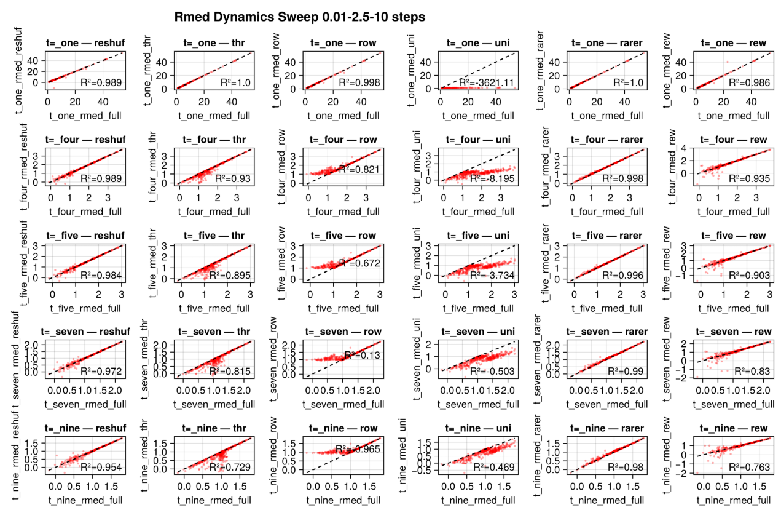**Figure 6. Two-stage recovery is general. R²(step vs full) vs t (log axis) for steps (thr, row, reshuf, rew) at mid IS and mid ρ.**

